**SMART DOOR**

**(Manual Door Latch Automation)**

**B.Tech Mini Project**

*Presented by:*

**Bhaskar (201600108)**

**Basit Halim (201600112)**

**Mayank Prakash (201600029)**

*Under the Guidance of:*

**Mrs. Prativa Rai**

**Associate Professor**

**Department of Computer Science and Engineering**

**Sikkim Manipal Institute of Technology**



November 2019

**PROJECT COMPLETION CERTIFICATE**

This is to certify that **Mr. Basit Halim (Registration No. 201600112)** of Computer Science and Engineering Department of Sikkim Manipal Institute of Technology has worked under my supervision and guidance **01 May 2019** to **16 November 2019** and has successfully completed the project entitled “**Smart Door Manual Latch Automation** ” in partial fulfillment of the requirements for the award of Bachelor of Technology in Computer Science and Engineering.

Mrs. Prativa Rai  
Associate Professor

Computer Science & Engineering Department

Sikkim Manipal Institute Of Technology.

**DECLARATION**

We hereby declare that the work recorded in this project report entitled “**Smart Door Manual Latch Automation** ” in partial fulfillment for the requirements of award of B.Tech in Computer Science & Engineering Department from Sikkim Manipal Institute of Technology (A constituent college of Sikkim Manipal University) is a faithful and bonafide project work carried out at **SMIT, Majitar** under the supervision and guidance of **Mrs. Prativa Rai**, Associate Professor, Computer Science & Engineering Department, Sikkim Manipal Institute Of Technology. The results of this investigation reported in this project have so far not been reported for any other Degree/Diploma or any other technical forum. The assistance and help received during the course of investigation have been duly acknowledged.

**Mr. Basit Halim (Reg 201600112) ________________________________**

**ACKNOWLEDGEMENT**

Presentation inspiration and motivation have always played a key role in the success of any venture. We feel to acknowledge our indebtedness and deep sense of gratitude to our guide **Mrs. Prativa Rai** whose valuable guidance and kind supervision gave us throughout the course which shaped the present work as it shows.

We pay our deep sense of gratitude to **Prof. (Dr.) Kalpana Sharma, H.O.D, Computer Science & Engineering Department, Sikkim Manipal Institute of Technology** to encouraged us to the highest peak and to provide us the opportunity to prepare for the project.

We are obliged to our project coordinators **Dr. Sandeep Gurung, Mr. Santanu Kumar Misra, Mr. Biraj Upadhyaya and Ms. Nitisha Pradhan** for elevating inspiration and kind supervision in completion of our project.

We would like to thank our **Computer Science & Engineering Department, Sikkim Manipal Institute of Technology** and to all the faculty members for giving us continuous support and guidance that has helped us in completion of our project.

**DOCUMENT CONTROL SHEET**

|  |  |  |
| --- | --- | --- |
| 1. | Report No. | CSE/Mini Project/B.Tech/BU/Group no 20/2019 |
| 2. | Title of the report | Smart Door Manual Latch Automation |
| 3. | Type of Report | Technical |
| 4. | Authors | Mr. Bhaskar (Reg 201600108)  Mr. Basit Halim (Reg 201600112)  Mr. Mayank Prakash (Reg 201600029) |
| 5. | Organizing Unit | SMIT |
| 6. | Language of the document | English |
| 7. | Abstract | With the advent of new concepts like Internet of Things and development of advanced authentication and security technologies, the need for smarter security systems has been growing. The design and development of an automatic manual door latch system and remote control of smart door lock have been reported in this project. |
| 8. | Security Classification | General |
| 9. | Distribution statement | General |

**CONTENT**

|  |  |  |
| --- | --- | --- |
| **SI No.** | **Title** | **Page No.** |
| 1.  2.  3.  4.  5.  6.  7.  8.  9.  10.  11.  12.  13.  14. | Abstract  Introduction  Literature Survey  Problem Definition  Solution Strategy  Hardware  Design  Implementation  Results  Conclusion  Limitation  Future Scope  Gantt Chart  References | 9  10  11  12  13  14-15  16-17  18  19-21  22  23  24  25  26 |

**CONTENT OF DIAGRAM**

|  |  |  |
| --- | --- | --- |
| **SL. No.** | **Name of Figure** | **Page No.** |
| 1 | CIRCUIT DIAGRAM | 16 |
| 2 | DESIGN OF WORKING MODULE | 17 |
| 3 | CODE FOR NODE MCU | 18 |
| 4 | IMAGE OF PROJECT | 19 |
| 5 | BLYNK APP | 20 |
|  |  |  |
|  |  |  |
|  |  |  |
|  |  |  |
|  |  |  |
|  |  |  |

**LIST OF TABLES**

|  |  |  |
| --- | --- | --- |
| **SL. No.**  1 | **Table Name**  Literature Survey | **Page No.**  11 |
| 2 | GANTT Chart | 25 |

**ABSTRACT**

Smart home security and remote monitoring have become vital and indispensable in recent times, and with the advent of new concepts like Internet of Things and development of advanced authentication and security technologies, the need for smarter security systems has only been growing. The design and development of an automatic manual door latch system and remote control of smart door lock have been reported in this project. The system also includes a web-based remote monitoring, an authentication module, and a bare-bones embedded Internet Of Things server, which transmits data through blynk app, and the owner can then remotely control the lock by responding through app virtual buttons to unlock the door. This system finds wide applications in smart homes where the physical presence of the owner at all times is not possible, and where a remote authentication and control is desired. The system has been implemented and tested using the Node MCU ESP8266 board, Python along with IFTTT are used to program the various control modules.

**INTRODUCTION**

Application services based on information and communication technology has been actively investigated in the knowledge information society. In particular, the most rapid growth can be observed in services which combines more than two elements for the same purpose. Convergence services prove to represent Internet of Things (IoT) technology intricated with android apps to provide interactive communication through wired or wireless networks. Furthermore, the Internet Of Things industry is deemed the core industrial field of the future. They provide convenient and effective services in any place at any time, beyond the technical and economical restrictions, as well as the temporal and spatial limits by providing services required in various kinds of fields. It also aids the distribution of intelligent terminals which includes smart phones, in conjunction with the advancement of information and communication technology. Meanwhile, the demand on convenience and speed has increased in the economic sectors of modern society. The financial sector, amongst other fields, require these technologies as mentioned above. In each house, the physical locks used to manage the door open/close systems are done physically by people. Accordingly, it is highly possible that the physical keys can be lost, stolen, or reproduced. It is thereby required to strengthen the security for the system in its administrative aspects.

**LITERATURE SURVEY**

Table 1: Literature Survey

|  |  |  |  |
| --- | --- | --- | --- |
| **Sl.No.** | **Organization** | **FIindings** | **Relevance to Project** |
| 1. | www.ableton.com | Stats about growth and scope of this project. | Information about different types of automation techniques |
| 2. | www.waves.com | Automation of manual latch. | Automating manual latches using motors and gears. |
| 3. | www.blynk.com | Using blynk app | To control the device through device |
| 4. | www.hardwarestore.com | Knowledge of hardware devices like relay,nodes etc. | Connection of hardware devices. |
| 5. | www.smartconnect.com | Knowledge about connecting wires for different purposes | Knowledge about connecting wires through the relay for an alternating current in the circuit |
| 6. | www.codefornode.com | Coding in c sharp for node MCU | Coding to connect node MCU ESP8266 to hotspot and blynk app |
| 7. | www.sasta.com | Cheapest parts that can be used in a project | We used cheap parts to make the project budget friendly and marketable. |

**PROBLEM DEFINITION**

The current door locking and unlocking systems available in the market are manual. And of those which are automatic, they are way too costly and out of reach for the middle and lower strata. People need to physically go and open the door in order to let someone in. Many security breaches are possible in the physical model. Also, all the locks made till today can be manipulated as they are placed outside the door. We have designed a door automation device that can be automatically opened by click of a virtual button authenticated by ipv4/6 security protocols.

**SOLUTION STRATEGY**

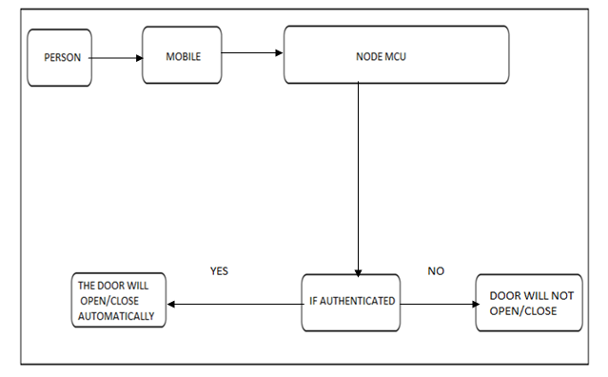

FIGURE 1: WORKING MODULE

**HARDWARE COMPONENTS USED**

Table 2: Servo Motor Specifications

|  |  |
| --- | --- |
| Modulation | Analog |
| Torque | **4.8V:** 25.00 oz-in (1.80 kg-cm) |
| Speed | **4.8V:** 0.12 sec/60° |
| Weight | 0.32 oz (9.0 g) |
| Dimensions | Length:0.91 in (23.0 mm) Width:0.48 in (12.2 mm) Height:1.14 in (29.0 mm) |
| Motor Type | 3-pole |
| Gear Type | Plastic |
| Rotation/Support | Bushing |
| Rotational Range | () |
| Pulse Cycle | ([add](https://servodatabase.com/add-data?make=towerpro&model=sg90)) |
| Pulse Width | 500-2400 µs |
| Connector Type | JR |

Table 3: Bolt Iot Wifi Module Specification

|  |  |
| --- | --- |
| Parameters | Details |
| Connectivity and Processing Module | ESP8266 with custom firmware |
| MCU | 32-bit RISC CPU: Tensilica Xtensa LX106 |
| Power | 5V/1A DC via Micro-USB port or 5V and GND pins |
| Operating Voltage | 3.3 V |
| CPU clock frequency | 80 MHz |
| GPIO Pins | 5 Digital Pins |
| Boot time | Less Than 1 seconds |

Table 4: Arduino Uno Technical Specifications

|  |  |
| --- | --- |
| Microcontroller | [ATmega328P](https://components101.com/microcontrollers/atmega328p-pinout-features-datasheet) – 8 bit AVR family microcontroller |
| Operating Voltage | 5V |
| Recommended Input Voltage | 7-12V |
| Input Voltage Limits | 6-20V |
| Analog Input Pins | 6 (A0 – A5) |
| Digital I/O Pins | 14 (Out of which 6 provide PWM output) |
| DC Current on I/O Pins | 40 mA |
| DC Current on 3.3V Pin | 50 mA |
| Flash Memory | 32 KB (0.5 KB is used for Bootloader) |
| SRAM | 2 KB |
| EEPROM | 1 KB |
| Frequency (Clock Speed) | 16 MHz |

Table 5: Solderless Breadboard Specification

|  |  |
| --- | --- |
| Voltage | 300 V |
| Model Number | LYSB01DDI54II-ELECTRNCS |
| Part Number | REES - BREADBOARD |
| TIE Points | 400 |
| Size | 82mm * 55mm * 8.5mm |

**DESIGN**

_

+

MOTOR

NODE MCU

ARDUINO UNO

D4

D5

GND

5V

RELAY BOARD

Gnd

IN2

IN1

Vin

A

C

B

A

C

B

A

FIGURE 2: CIRCUIT DIAGRAM

**IMPLEMENTATION**

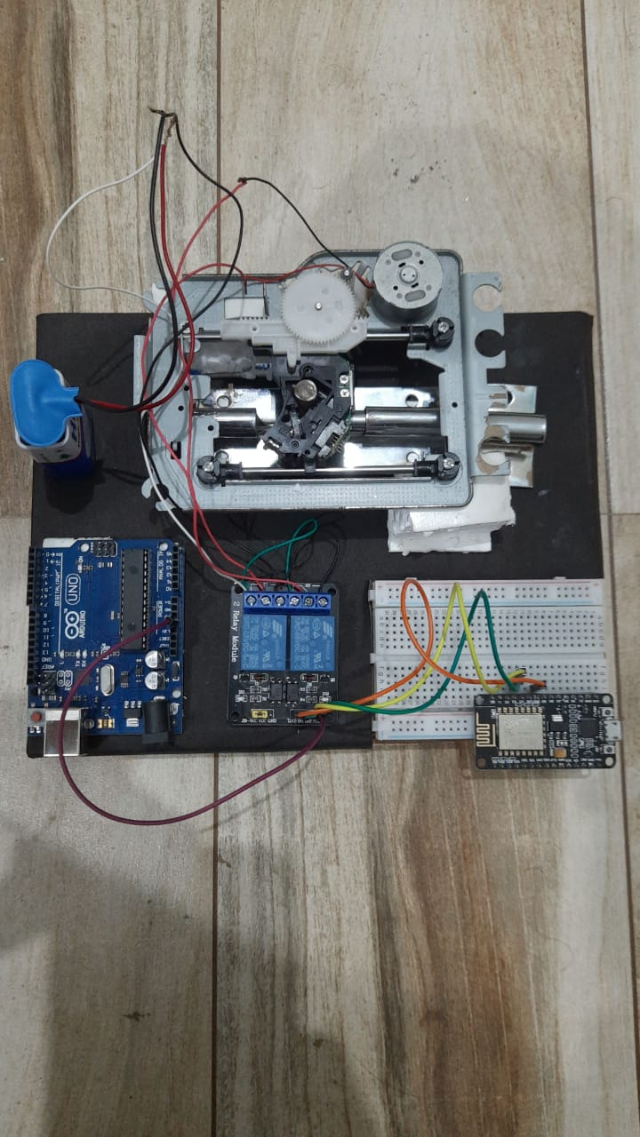

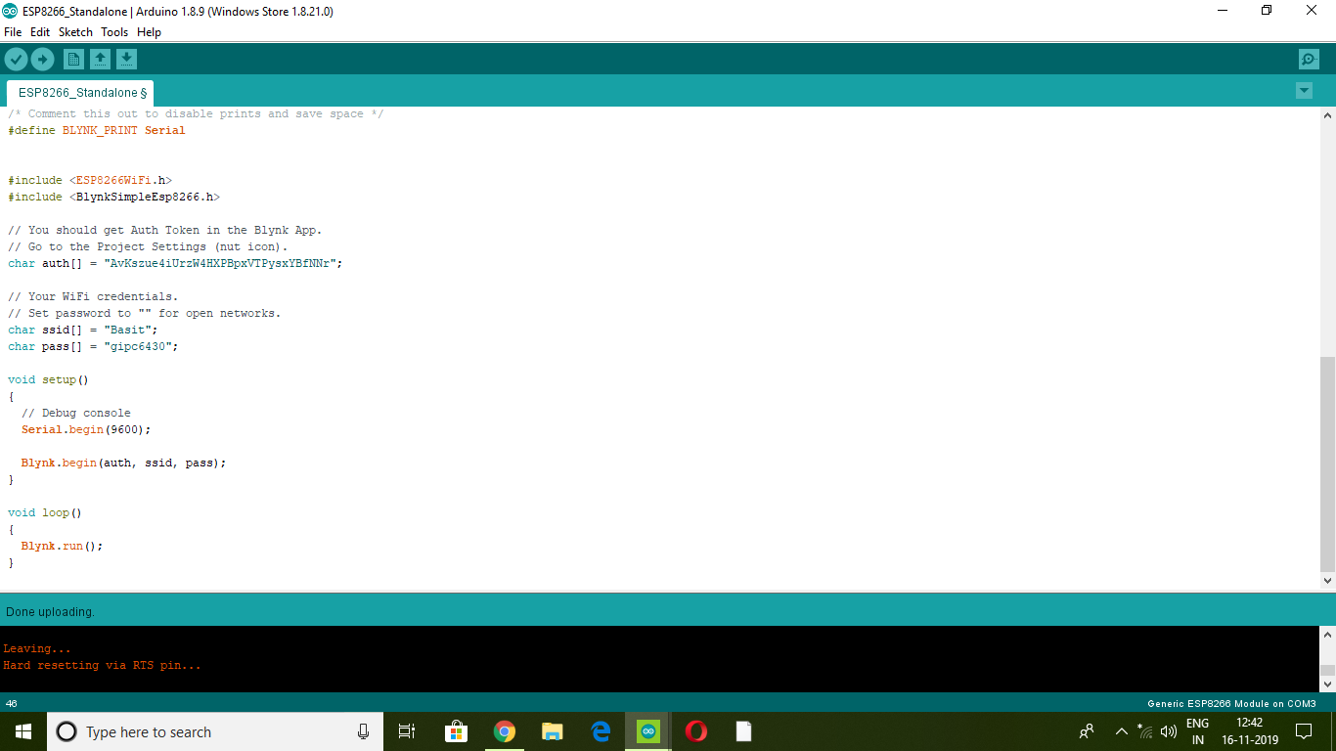FIGURE 3: CODE FOR NODE MCU

**RESULTS**

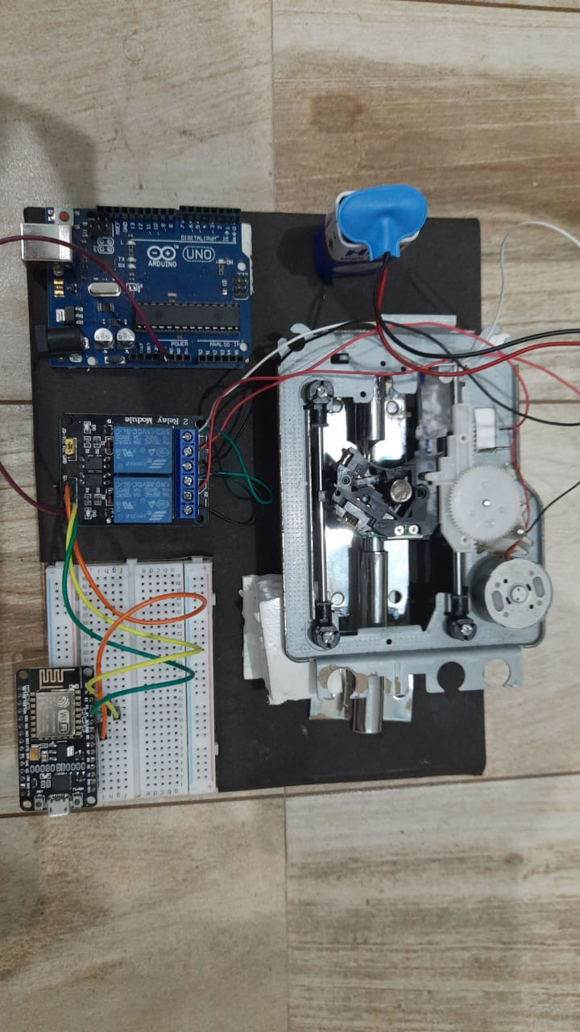In the end, a prototypic version of door latch automator was successfully made. This was accomplished using largely hardware components and apps such as Blynk. Here is a snapshot of the working model of the project.

FIGURE 4: IMAGE OF PROJECT

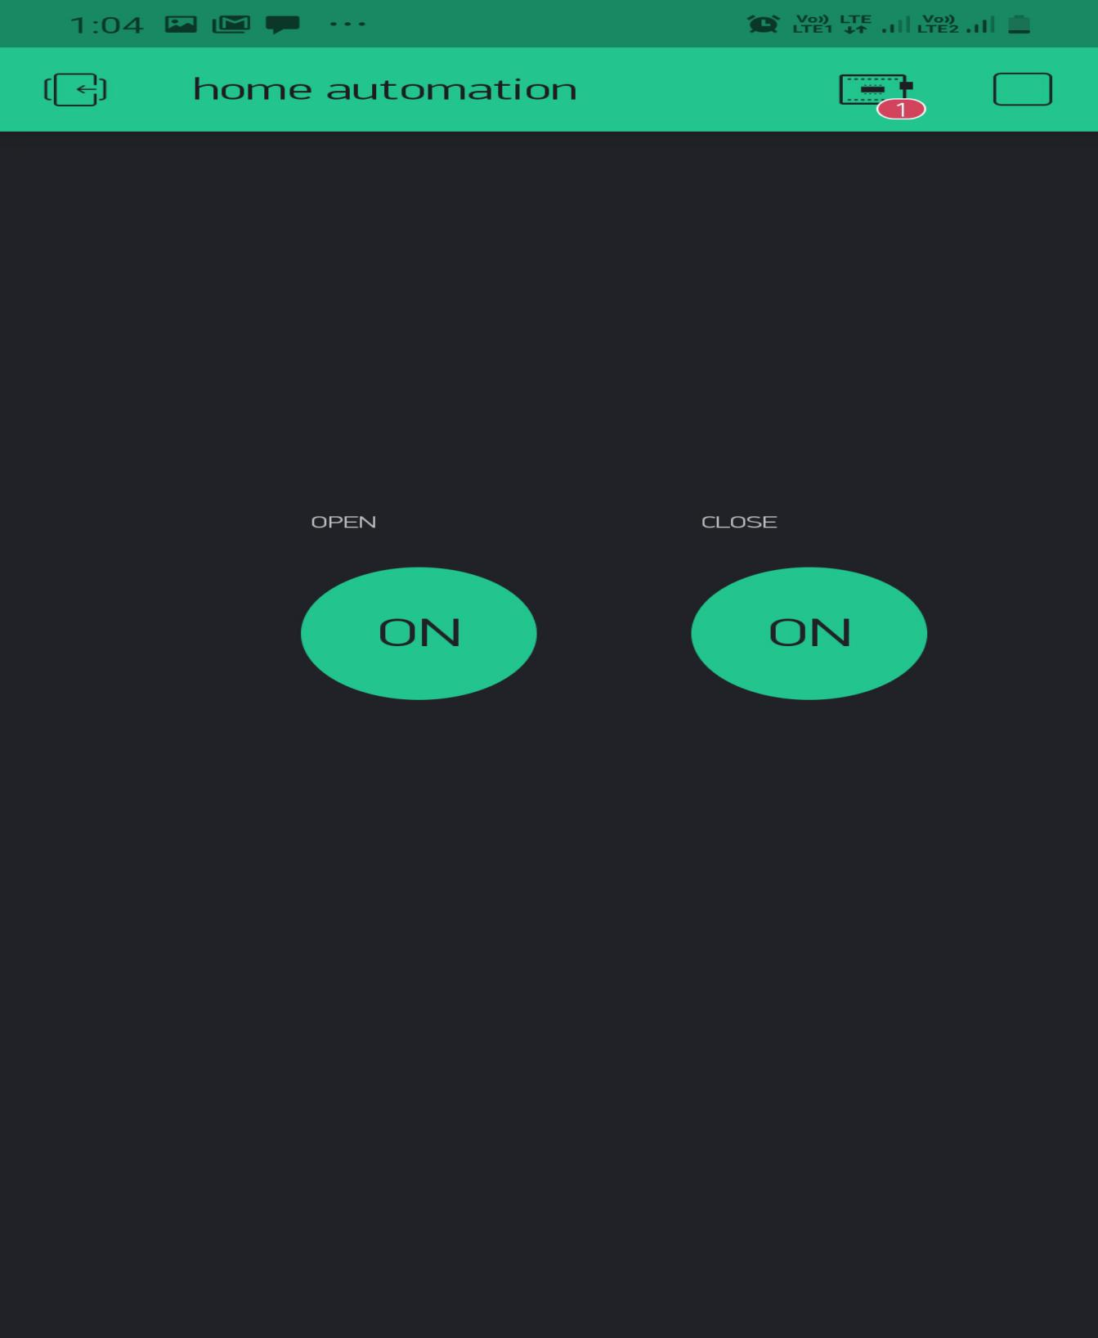

FIGURE 5: BLYNK APP

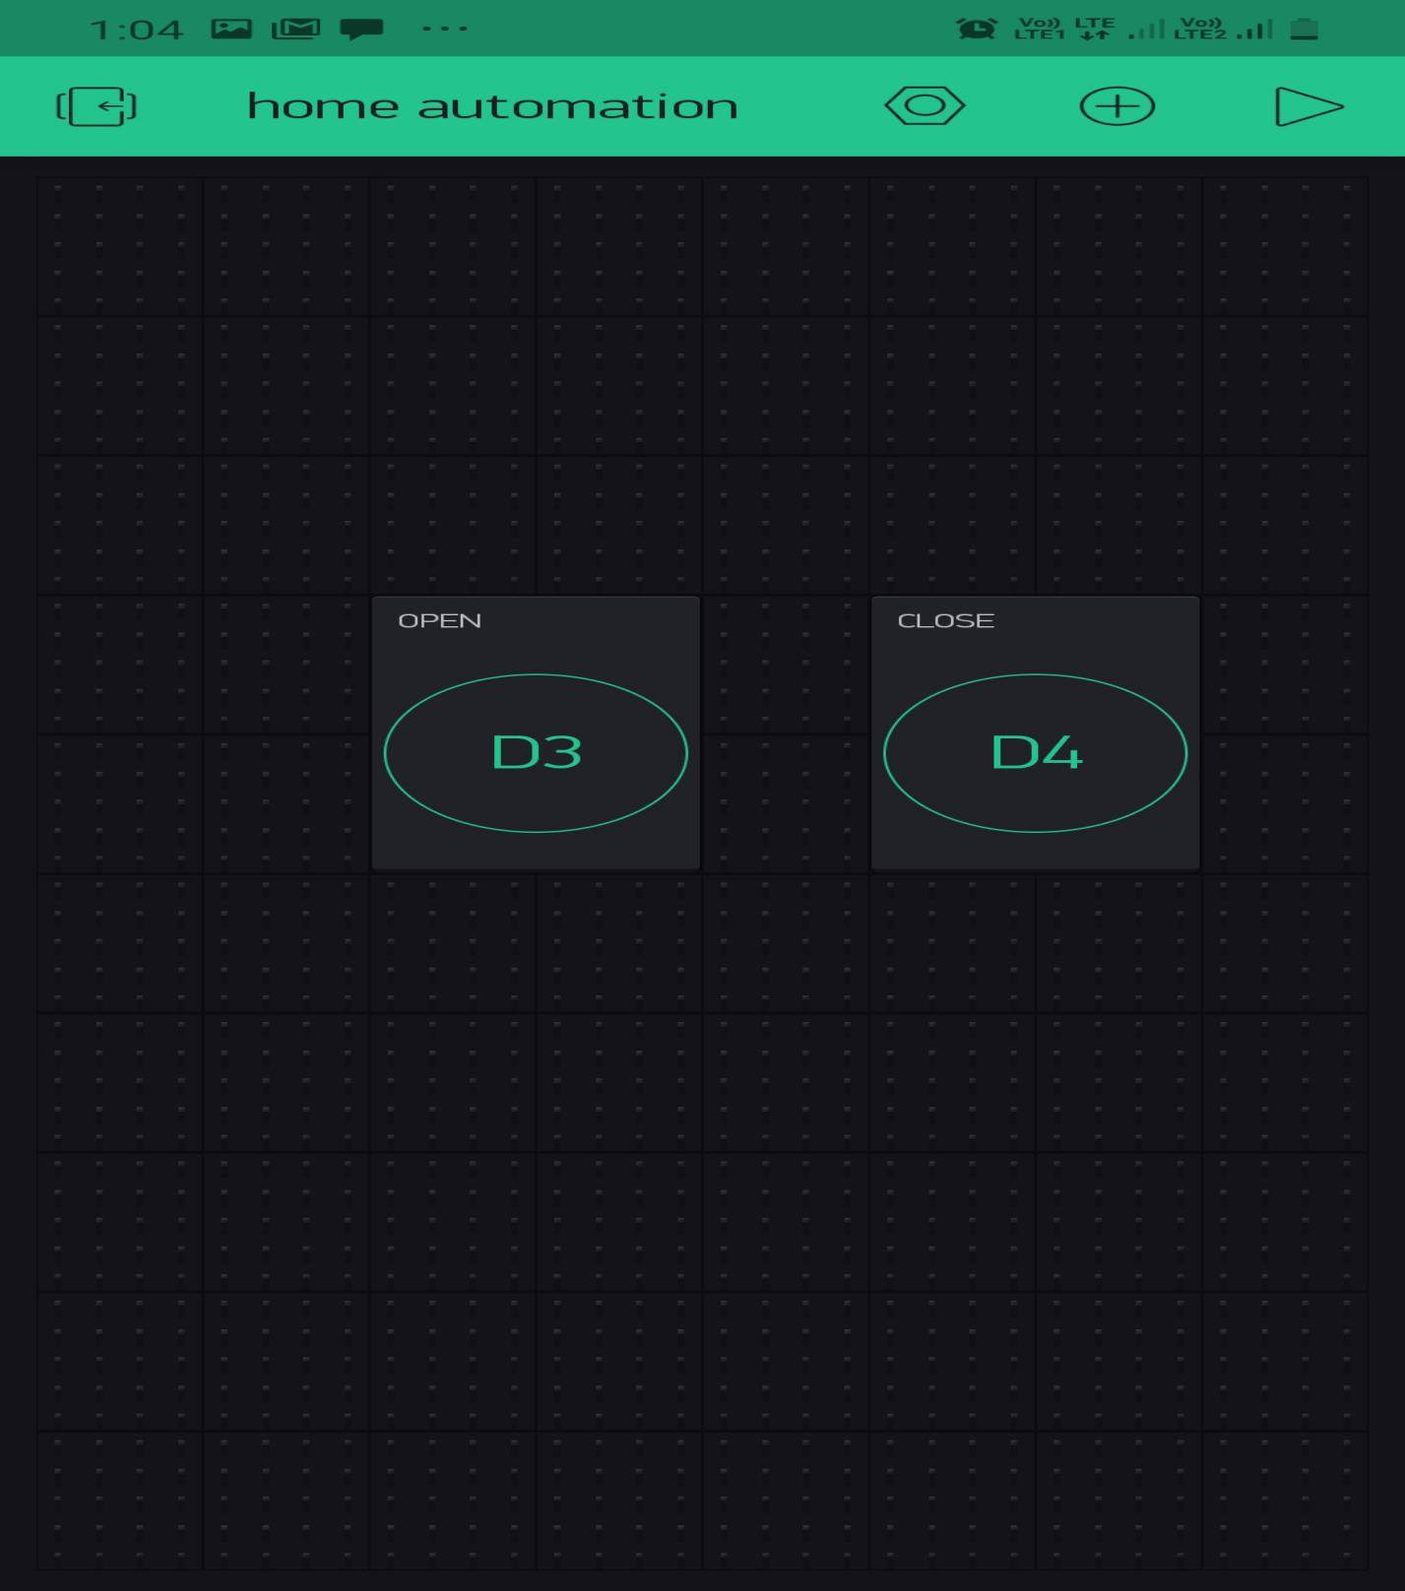

FIGURE 6: BLYNK APP

FIGURE 6:

**CONCLUSION**

From the above project we can conclude that using a simple yet efficient technology at a very cheap price, we can automate doors for middle and lower class houses which can’t afford high end door automation. This project aims at allowing these people to automate their door latches.

To end we would like to say that simple parts and simple things put together can make into something great. A simple combination of a relay, CD driver, ESP 8266 Node MCU has been put together to make this project. It is one of the few if not the only manual door latch automation project to be made at this price.

**LIMITATIONS**

1. It does not work without internet.
2. It works only in a given specific range.
3. It needs continuous power supply.
4. System malfunctions due to human errors.

**FUTURE SCOPE**

1. To improve the system we can add a camera on the gate which will take the image of the people and recognize its face.
2. There can be a smart phone application enhancement for this project that is, creating a smart phone app to give access to guests when person is away from his/her home.
3. This can also extend to, if someone is trying to break in the door alarm will start beeping.

**GANTT CHART**

|  |  |
| --- | --- |
|  | Proposed Activity |
|  | Ongoing Activity |
|  | Activity Achieved |

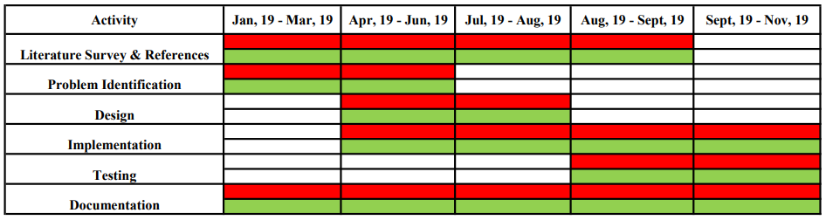

**REFERENCES**

1. [www.ableton.com](http://www.ableton.com/) [15/08/19 12:08:23]
2. [www.waves.com](http://www.waves.com/)    [15/08/19 15:42:03]
3. [www.ipcam.com](http://www.ipcam.com/)    [17/08/19 09:53:43]
4. <https://youtube/d8_XXNcGYgo>  for aurdino tuitorials   [17/08/19 18:32:34]
5. <https://youtube/wM0hz1_fMI4> for windows application form  [19/08/19 10:05:55]
6. [www.boltiot.com](http://www.boltiot.com/) for wifi module tutorials  [19/08/19 22:43:09]